**6. Coding Assignments**

1. **Hello World Program**: Write a Java program that prints "Hello World!!" to the console.
2. **Compile with Verbose Option**: Compile your Java file using the -verbose option with javac. Check the output.
3. **Inspect Bytecode**: Use the javap tool to examine the bytecode of the compiled .class file. Observe the output.

🡪Code

class HelloWorld{

public static void main(String p[]){

System.out.println("Hello World!");

}

}  
  


With verbose option:

-verbose Output messages about what the compiler is doing

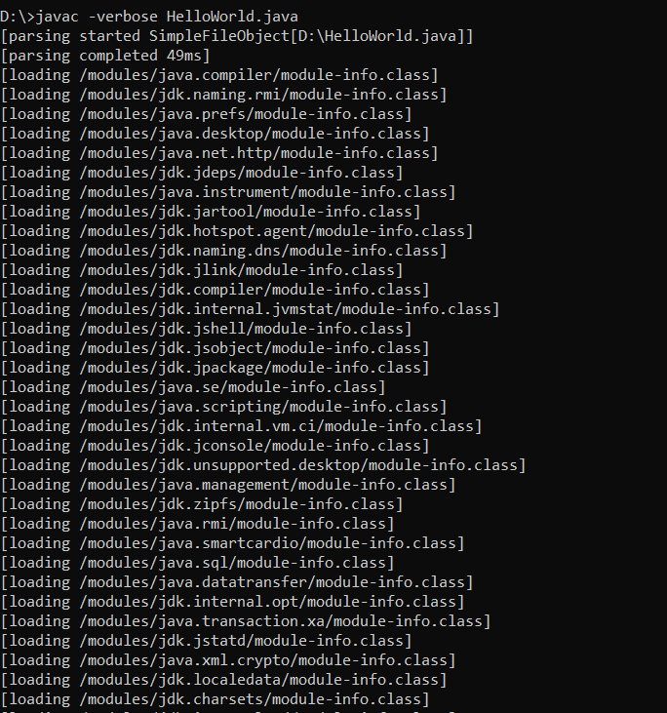

With javap

-c Disassemble the code

